Lecture 3
Listing-Order Paragraphs

At the end of our lecture you will be able to answer the following questions:

- What is listing order?
- What are the three parts of a paragraph?
- What are the two parts of a topic sentence?
- What does the controlling idea do?
- What are transition signals? What are some listing-order transition signals?
- What is unity in a paragraph?
- What are two ways to write a concluding sentence?
- What is an outline? How does an outline help writers?

Today, you will learn how to write paragraphs that use the listing-order pattern of organization. You will also study and practice:
• the three parts of a paragraph
• listing-order transition signals
• paragraph unity
• simple outlining
• compound sentences
• two common sentence errors

Organization
Organization is one of the most important writing skills. A well-organized paragraph is easy to read and understand because the ideas are in a recognizable pattern. Just as you organize tools on a workbench or clothes in a closet, you also organize sentences in a paragraph. Listing order is a pattern often used in English.
In a listing-order paragraph, you divide the topic into separate points. Then you discuss one point, and then another point, and then a third point, and so on.
There are three keys to writing a listing-order paragraph:
- Begin with a sentence that names your topic and says it has several points.
- Write about each point separately.
- End with a sentence that reminds your reader about the points you just discussed.

MODEL
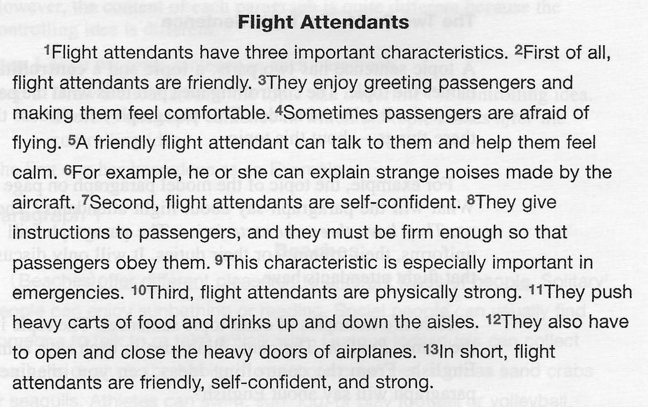

Questions on the Model
- Look at the title. What is the topic of this paragraph?
- Look at the first sentence. What does it say about the topic?
- How many points should the reader look for in this paragraph?
- List the points here: __________________
- Now look at the last sentence. What information does it repeat?

Outlining

Making an outline is another part of prewriting. Once you get ideas to write about, you need to organize them. An outline helps you do this. For example,in the Model about flight attendants we chose three characteristics to write about: friendliness, self-confidence, and physical strength. To complete the outline, we add a topic sentence and a concluding sentence.

Simple Outline
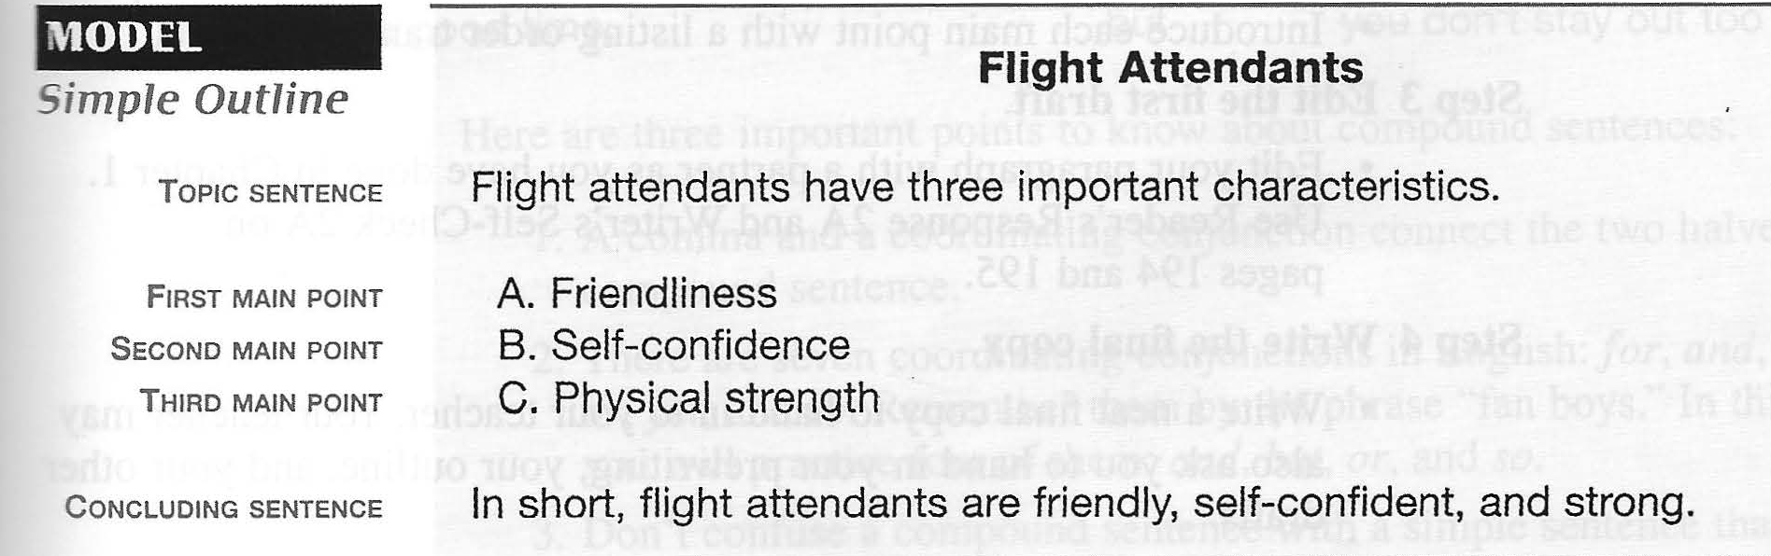

When you write an outline, try to make the main points (A, B, C, and so on) the same-all adjectives, all nouns, all verb phrases, or all sentences.

